Article Title for International Journal of Mechatronics, Robotics, and Artificial Intelligence
Author One*¹, Author Two^{2,3}, Author Three³
¹Org Division, Org Name, State Name, Country Name
²Org Division, Org Name, State Name, Country Name
³Org Division, Org Name, State Name, Country Name
Correspondence
*Corresponding Author name
Corresponding Author address
Email: authorone@mail.com

Abstract
Abstracts must be limited to a maximum of 300 words. They should succinctly convey the core content of the manuscript while addressing the following components in a coherent narrative format, without employing explicit subheadings: Purpose: Clearly articulate the central issue or research question being explored, using terminology that remains understandable to a broad scientific readership. Innovation or Approach: Concisely describe the methodology or technological advancement implemented to tackle the identified problem. Findings: Summarize the principal outcomes and key insights derived from the study. Interpretation: Offer a brief synthesis of the implications or relevance of the results. Translational Relevance: Highlight the potential applicability of the findings in clinical settings and their broader implications for healthcare practice. An expanded and comprehensive discussion of each of these aspects is expected within the main sections of the manuscript. Note: While the structure of the manuscript body may be tailored by the authors, the inclusion of the following sections is mandatory: Introduction, Methods and Procedures, Results, Conclusion, and References. Optional sections such as Acknowledgements and Appendices may be included at the authors' discretion.
Keywords
Provide a minimum of FOUR keywords or key phrases, listed in alphabetical order and separated by commas.

Introduction
Manuscripts must adhere to the established formatting and stylistic conventions of the IJMRAI. For any formatting, structural, or content-related aspects not explicitly addressed in the current set of instructions, contributors are advised to consult the most recent issue of IJMRAI to ensure alignment with the journal’s presentation standards.

Preparing Your Paper

Paper Size:
Prepare your paper in full-size format on US letter size paper (8.5 by 11 inches).

Type Sizes and Typefaces:
Follow the font type sizes specified in Table I. The font type sizes are given in points, same as in the MS Word font size points. Times New Roman is the preferred font.

Paper Margins:
Paper margins on the US letter size paper are set as follows: top = 0.75 inches, bottom = 1 inch, side = 0.625 inches. Each column measures 3.5 inches wide, with a 0.25-inch gap between the two columns.

TABLE I.
TYPE SIZE FOR PAPERS
Type size | Appearance
Type size | Regular | Bold | Italic
10 | Section titles,  references,  table captions,  figure captions.
10 |  | Abstract, Keywords. | Abstract
10 | Main text,  equations. |  | Subheading
10 | Authors' names | Authors' names
21 | Paper title | Paper title

Paper Styles:
Text columns must be fully justified on both the left and right margins to ensure a clean and professional appearance. On the final page of the manuscript, adjust column lengths as necessary to maintain visual balance and achieve equal column height. Authors should enable automatic hyphenation to optimize text flow and reduce uneven spacing. All visual materials including figures, charts, diagrams, and photographs must be of high resolution (minimum 300 dpi) to guarantee clarity and quality in both digital and print formats.

Helpful Hints

Figures and Tables
Try to position figures and tables at the tops and bottoms of columns and avoid placing them in the middle of columns. Large figures and tables may span across both columns. Figure captions should be centered below the figures; table captions should be centered above. Avoid placing figures and tables before their first mention in the text. Use the abbreviation “Fig. #,” even at the beginning of a sentence.
In case of dimensions of the figure are equal to the page width, it can be inserted as in Fig. 1.
Figure axis labels are often a source of confusion. Use words rather than symbols. For example, as shown in Fig. 1, write “Magnetization,” or “Magnetization (M)” not just “M.” Put units in parentheses. Do not label axes only with units. In the example, write “Magnetization (A/m)” or “Magnetization (A⋅m⁻¹).” Do not label axes with a ratio of quantities and units. For example, write “Temperature (K),” not “Temperature/K.”
Multipliers can be very confusing. Write “Magnetization (kA/m)” or “Magnetization (10³ A/m).” Figure labels should be legible, at 8-point type.

References
Number citations consecutively in square brackets [1]. Punctuation follows the bracket [2]. Refer simply to the reference number, as in [3]. Use “Ref. [3]” or “Reference [3]” at the beginning of a sentence: “Reference [3] was the first …”
Number footnotes separately in superscripts. Place the actual footnote at the bottom of the column in which it was cited. Do not put footnotes in the reference list. Use letters for table footnotes (see Table I). IJMRAI Journal no longer use a journal prefix before the volume number. For example, use “IEEE Trans. Magn., vol. 25,” not “vol. MAG-25.”
Give all authors’ names; use “et al.” if there are six authors or more [4]. Papers that have not been published, even if they have been submitted for publication, should be cited as “unpublished” [4]. Papers that have been accepted for publication should be cited as “in press” [5]. In a paper title, capitalize the first word and all other words except for conjunctions, prepositions less than seven letters, and prepositional phrases.
For papers published in translated journals, first give the English citation, then the original foreign-language one [6].

Abbreviations and Acronyms
All abbreviations and acronyms must be clearly defined upon their first appearance in the main body of the text, regardless of whether they have been introduced in the abstract. Commonly recognized abbreviations such as IEEE, SI, MKS, CGS, ac, dc, and rms are exceptions and need not be defined. Authors are advised to avoid the use of abbreviations or acronyms in the manuscript title unless their inclusion is essential for clarity or precision.

Equations
Number equations consecutively with equation numbers in parentheses flush with the right margin, as in (1). To make your equations more compact, you may use the solidus (/) and the exp function, etc. Italicize Roman symbols for quantities and variables, but not Greek symbols. Use an en dash (–) rather than a hyphen for a minus sign. Use parentheses to avoid ambiguities in denominators. Punctuate equations with commas or periods when they are part of a sentence, as in

$\cos^{3}θ=\frac{1}{4}\cos{θ}+\frac{3}{4}\cos{3θ}$ (1)

Symbols in your equation should be defined before the equation appears or immediately following. Cite equations using “(1),” not Eq. (1)” or “equation (1),” except at the beginning of a sentence: “Equation (1) is …”

Other Recommendations
The use of Roman numerals for section headings is optional. However, do not number the ACKNOWLEDGMENT and REFERENCES sections, and begin subheadings with capital letters. Use two spaces after periods. Hyphenate compound modifiers, such as “zero-field-cooled magnetization.” Avoid dangling participles—for example, instead of writing “Using (1), the potential was calculated,” use “The potential was calculated using (1)” or “Using (1), we calculated the potential.” Always place a zero before decimal points (e.g., “0.25,” not “.25”). Use “cm³” rather than “cc.” Do not combine full unit names with abbreviations (write either “Wb/m²” or “webers per square meter,” not “webers/m²”). When units appear in running text, spell them out—for example, “…a few henries,” rather than “…a few H.” If English is not your first language, ask a native English-speaking colleague to review your manuscript. Do not include page numbers in your submission.

Units
Use either SI (MKS) or CGS as primary units. (SI units are encouraged.) English units may be used as secondary units (in parentheses). An exception would be the use of English units as identifiers in trade, such as “3.5-inch disk drive.”
Avoid mixing SI and CGS units, such as using amperes for current and oersteds for magnetic field strength as this can cause confusion and result in dimensionally inconsistent equations. If the use of mixed units is unavoidable, explicitly specify the units of each quantity within the equation.

Some Common Mistakes
Remember that “data” is a plural noun. In American English, commas and periods are placed inside quotation marks, as in “this period.” When a parenthetical phrase appears at the end of a sentence, the punctuation goes outside the closing parenthesis (like this). However, if the entire sentence is parenthetical, punctuation remains inside the parentheses. A smaller graph inside another is called an “inset,” not an “insert.” Use “alternatively” rather than “alternately,” unless referring to something that alternates. Avoid using “essentially” when you mean “approximately” or “effectively.” Distinguish between commonly confused
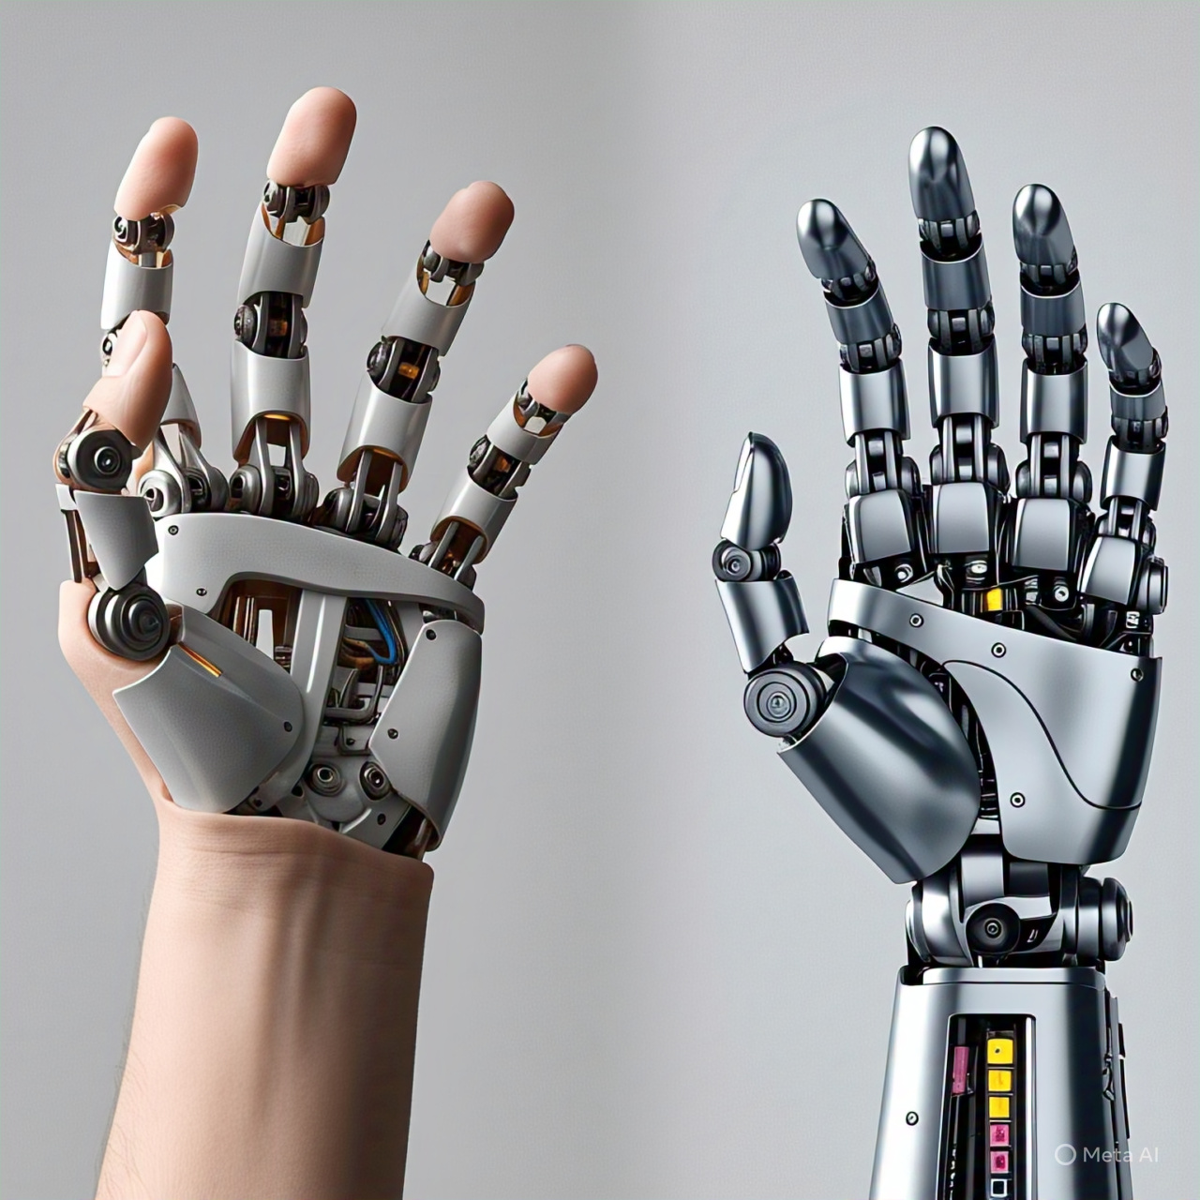

Fig. 1. Wide Image

homophones such as “affect” vs. “effect,” “complement” vs. “compliment,” “discreet” vs. “discrete,” and “principal” vs. “principle.” Do not misuse “imply” and “infer.” The prefix “non” should be attached directly to the word it modifies, usually without a hyphen. Note that there is no period after “et” in “et al.” Additionally, “i.e.” stands for “that is,” and “e.g.” stands for “for example.” A recommended reference for scientific writing style is [7].

Acknowledgment
In accordance with American English conventions, the preferred spelling is “acknowgment,” omitting the “e” after the “g.” Authors should avoid overly formal or impersonal phrasing such as “One of us (R.B.G.) thanks…”. Instead, use direct attribution (e.g., “R.B.G. thanks…”). Acknowledgment of financial support, institutional sponsorship, or technical assistance should be included in an unnumbered footnote on the first page of the manuscript.
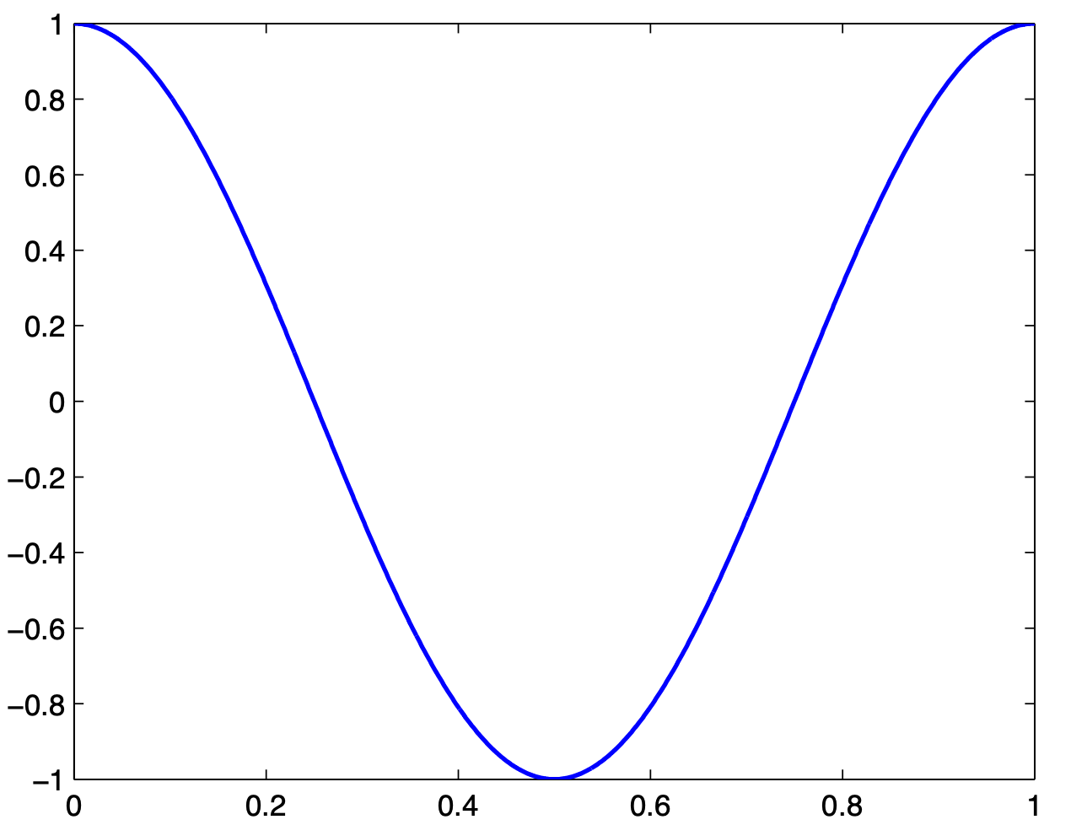
Applied Field (10³ A/m)
Fig. 2. Magnetization as a function of applied field.
Note how the caption is centered in the column.

Conflict of Interest
All authors are required to disclose any potential conflicts of interest that may influence the content or interpretation of the manuscript. This declaration must be included in the Conflict of Interest section of the submitted manuscript. In cases where no conflicts of interest exist, authors must explicitly state this to ensure transparency. The following standard statement may be used: “The authors have no conflict of relevant interest to this article.”

References (Written Using Mendely)
- M. King, B. Zhu, and S. Tang, “Optimal path planning,” Mobile Robots, vol. 8, no. 2, pp. 520-531, 2001, doi: 10.33971/ijmrai.00.0.0.
- H. Simpson, “Dumb Robots,” 3rd ed., Springfield: UOS Press, pp.6-9, 2004, doi: 10.33971/ijmrai.00.0.0.
- M. King and B. Zhu, “Gaming strategies,” in Path Planning to the West, vol. 2, S. Tang and M. King, Eds. Xian: Jiaoda Press, pp. 158-176, 1998, doi: 10.33971/ijmrai.00.0.0.
- B. Simpson, “Title of paper goes here if known,” unpublished, 2020, doi: 10.33971/ijmrai.00.0.0.
- J. Lu, “Title of paper with only the first word capitalized,” J. Name Stand. Abbrev., 2022, doi: 10.33971/ijmrai.00.0.0.
- Y. Yorozu, M. Hirano, K. Oka, and Y. Tagawa, “Electron spectroscopy studies on magneto-optical media and plastic substrate interface,” Digest 9th Annual Conf. Magnetics Japan, 1987, doi: 10.33971/ijmrai.00.0.0.
- M. Young, “The Technical Writer’s Handbook,” Mill Valley, CA: University Science, 1989, doi: 10.33971/ijmrai.00.0.0.

